Report of the g30_keyboard_encoder Circuit
- Circuit Description
- A description of the circuit's function, listing the inputs and outputs.
- Provide a pinout or symbol diagram.
- The VHDL description of the circuit
The purpose of this circuit is to encode a 64-bit signal into a 7-bit signal. The input is a signal "KEYS" representing 64 keys on a keyboard and the output "ASCII_CODE" is a 7-bit ASCII code. The circuit encodes all numbers as well as upper and lower case letters into their corresponding ASCII code. Figure X shows a pinout diagram of the circuit.
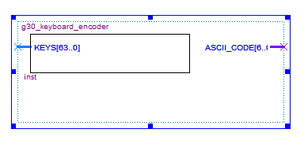
Figure X : Pinout Diagram of g30_keyboard_encoder Circuit

In order to encode the signal into its corresponding ASCII value, the circuit uses a 64-6 bit encoder. This 64-6 encoder is composed of four 16-4 bit encoders, and outputs the index number of the lowest significant bit of a 64-bit signal that is set to high. This component is therefore instantiated in the architecture of the circuit's VHDL code. Since each index value corresponds to a specific character, the circuit is programmed to output a specific 7-bit ASCII code depending on which bit is set to high.
In order to test the circuit, a test bench that generates every possible output value was designed. It uses a for-loop to set each bit of the "KEYS" signal to high one at a time. It is designed to wait for 10 ns in every iteration to make it possible to observe the output. Then, some random bit values are set to high in order to test for aleatory behavior.
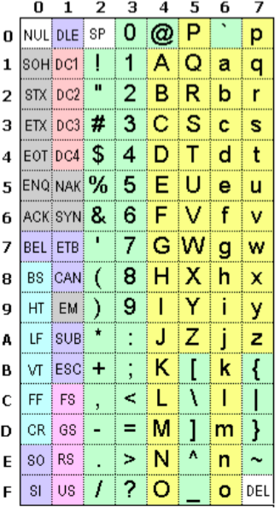
Figure 1. 7-Bit ASCII Table.

- Testing
First, the keyboard encoder circuit was tested using a VHDL test bench. Figure 1 shows all 7-bit hexadecimal ASCII codes. For our design, we are only concerned with columns 2 to 5. So, when the least-significant ‘1’ bit (LSB) of the input KEYS is at index 0, ASCII_CODE will have the value of the ‘SP’ character, i.e., 20₁₆. Similarly, if the ‘1’ LSB is at index 1, ASCII_CODE will equal 21₁₆, the ASCII value of ‘!’. This goes on until the last value of column 5, 5F₁₆ at character ‘_’. In our test bench, KEYS with a LSB ‘1’ at index 0, 1, 2 … 63 are first tested (all 64 valid inputs), then the error case (no key is pressed), then some arbitrary input (multiple keys pressed simultaneously). This error case was our design choice, to keep track of when no key is pressed, and to have an initial state. Table 1 summarizes the expected output to the arbitrary input.
Table 1. Expected ASCII_CODE to Arbitrary Input
KEYS (unsigned value) | Least significant ‘1’ index | ASCII_CODE (hexadecimal)
9223372071216611364 | 2 | 22
17870283321406128128 | 59 | 5B
2130303778816 | 36 | 44
1377042432 | 18 | 32
1378 | 1 | 21

Figure 2 shows the resulting waveform for each of the ‘valid’ inputs and the error case. These results confirm the expected behaviour, i.e., values of ASCII_CODE go from 20₁₆ to 5F₁₆, then 00₁₆ at the error case. Figure 3 shows the resulting waveform for the arbitrary input. Once again, this confirms the expected behaviour, since the expected values in Table 1 appear in the waveform.

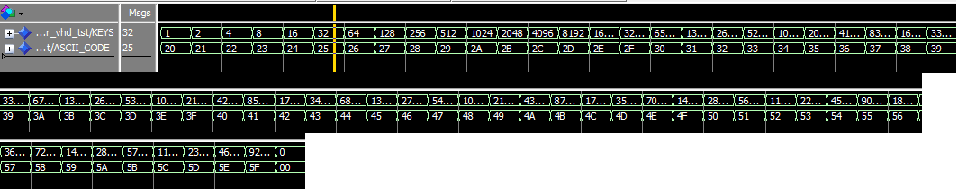
Figure 2. Valid Input and Error Condition Waveform.

Figure 3. Arbitrary Input Waveform.

Afterwards, the keyboard encoder, as well as the LED decoder, were tested together on the Altera DE1 board. To do this, the g30_keyboard_encoder was combined with the g30_7_segment_decoder in the g30_keyboard_to_LED VHDL file. Since only 10 switches are available to us on the board, we decided to test all the numeric characters, from ‘0’ to ‘9’. By the way we connected the pins to our circuit, the least significant character is associated with the least significant switch. So, if switch 0 is ON, character ‘0’ should appear on the 7 segment LED. The behavior is also such that only the least significant character will be shown. For example, if switch 1 and 5 are ON, only ‘1’ will be displayed on the LED. If no switches are on, the LED will be completely off. This port mapping to the Cyclone II EP2C20F484C7 can be seen in Figure 4.
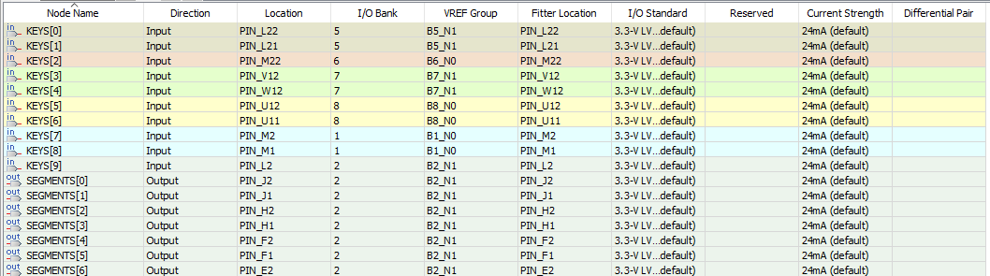
Figure 4. Keyboard Encoder Pin Mapping On the Cyclone II EP2C20F484C7.

Figure 5 shows the resulting 7 segment LED patterns for all test inputs. This confirms the expected behaviour, showing all characters from ‘0’ to ‘9’, as well as the error case (no keys are pressed). Note that we used the least significant 7-segment decoder (on the right), and the other ones stayed on. Even though we did not test all the possible characters with the Altera DE1 board, we are confident that the circuit behaves correctly, since we also tested a big percentage of possible inputs in the VHDL test bench as well.

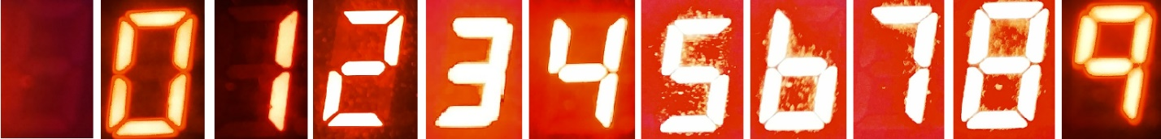
Figure 5. 7-Segment LED Output.

